**TIC-TAC-TOE**

A project report submitted for pre final year of

**Bachelor of Technology**

in

**Computer Science and Engineering**

By

Tasleema (N130975)

Reshma (N130954)

Vennela N130999)

Krishna Teja (N130252)

*Under the Supervision of*

**Mrs. Bhavani**



**Department of Computer Science and Engineering**

**Rajiv Gandhi University of Knowledge Technologies – Nuzvid**

**Nuzvid, Krishna – 521202**

November, 2017

**--------------------------------------------------------------------------------------------------------------------------------------**

**Rajiv Gandhi University of Knowledge Technologies**

**(A.P. Government Act 18 of 2008)**

**RGUKT-NUZVID, Krishna Dist - 521202**

Tele Fax: 08656 – 235557/235150

## CERTIFICATE OF COMPLETION

This is to certify that the work entitled, “**Tic-Tac-Toe”** is the bonafied work of ***Tasleema , ID No: N130975, Reshma , ID No: N130954 , Vennela , ID No: N130999 , Krishna Teja , ID No: N130252*** carried out under my guidance and supervision for pre final year project of **Bachelor of Technology** in the department of Computer Science and Engineering under RGUKT IIIT Nuzvid. This work is done during the academic session August 2017 – December 2017, under our guidance.

­­

---------------------------- ---------------------------

**Mrs. Bhavani Mr. Upendar**

Project SupervisorHead of Department

Lecturer Dept. of CSE Assistant Professor Dept. of CSE

RGUKT IIIT Nuzvid, Nuzvid RGUKT IIIT Nuzvid, Nuzvid

**--------------------------------------------------------------------------------------------------------------------------------------**

**Rajiv Gandhi University of Knowledge Technologies**

**(A.P. Government Act 18 of 2008)**

**RGUKT-NUZVID, Krishna Dist - 521202**

Tele Fax : 08656 – 235557/235150

## CERTIFICATE OF EXAMINATION

This is to certify that the work entitled, “**Tic-Tac-Toe”** is the bonafied work of ***Tasleema, ID No: N130975, Reshma, ID No: N130954, Vennela, ID No: N130999, Krishna Teja, ID No: N130252*** and here by accord our approval of it as a study carried out and presented in a manner required for its acceptance in pre final year of **Bachelor of Technology** for which it has been submitted. This approval does not necessarily endorse or accept every statement made, opinion expressed or conclusion drawn, as a recorded in this thesis. It only signifies the acceptance of this thesis for the purpose for which it has been submitted.

­­

---------------------------- ---------------------------

**Mrs. Bhavani Examiner**

Project SupervisorProject Examiner

Lecturer Dept. of CSE Lecturer Dept. of CSE

RGUKT IIIT Nuzvid, Nuzvid RGUKT IIIT Nuzvid, Nuzvid

**--------------------------------------------------------------------------------------------------------------------------------------**

**Rajiv Gandhi University of Knowledge Technologies**

**(A.P. Government Act 18 of 2008)**

**RGUKT-NUZVID, Krishna Dist - 521202**

Tele Fax: 08656 – 235557/235150

## DECLARATION

We, ***Tasleema, ID No: N130975, Reshma, ID No: N130954, Vennela, ID No: N130999, Krishna Teja, ID No: N130252*** hereby declare that the project report entitle “**Tic-Tac-Toe”** done by us under the guidance of **Mrs. Bhavani M.Tech.,** is submitted for pre final year of **Bachelor of Technology** in **Computer Science and Engineering** the academic session August 2017-December 2017 at RGUKT – Nuzvid.

We also declare that this project is a result of our own effort and has not been copied or imitated from any source. Citations from any websites are mentioned in the references.

The results embodied in this project report have not been submitted to any other university or institute for the award of any degree or diploma.

­­

**Date: 23-11-2017 Tasleema [N130975]**

**Place: Nuzvid Reshma [N130954]**

**Vennela [N130999]**

**Krishna Teja [N130252]**

**ACKNOWLEDGEMENT**

We would like to express our profound gratitude and deep regards to my guide ***Mrs. Bhavani*** for her exemplary guidance, monitoring and constant encouragement throughout the course of this thesis.

We are extremely grateful for the confidence bestowed in us and entrusting our project entitled “Tic-Tac-Toe”.

At this juncture we feel deeply honored in expressing our sincere thanks to her for making the resources available at right time and providing valuable insights leading to the successful completion of our project.

We would like to thank RGUKT Nuzvid Director, faculty and staff for their valuable suggestions and discussions.

Tasleema

Reshma

Vennela

Krishna Teja

**ABSTRACT**

Tic-Tac-Toe is one of the simple game, which is also called as noughts and crosses but in our local terms we called it as cross-zero game. Other may say differently this game but things are same. It is a pencil-and-paper game for two players, where player select X and O, as their playing item. It is played on the grid of 3×3. The player who succeeds in placing three respective marks in a horizontal, vertical, or diagonal row wins the game.

The main motto of our game is to make the computer perform a move based on the move of the user and try to win over the player.

**CONTENTS**

**I .Chapter 1**

1. **Introduction** ……………………………………………... 08
   1. Introduction ……………… 08
   2. Importance of Tic-Tac-Toe ……………………………… 09

**II. Chapter 2**

1. **Game Strategy** ……………………………………….. 10
2. **Player vs. Player**……………………………………….. 11
3. **Player vs. Computer**

3.1 Computer Preventing User Winning Moves ……………… 12

3.2 User Winning Chances …………………………. 14

1. **Conclusion and Future Scope**……………………………. 15

**References** ……………………………………………............ 16

**CHAPTER 1**

**1.1 INTRODUCTION**

Tic-Tac-Toe is not a challenging game for human beings. If you’re an enthusiast, you’ve probably moved from the basic game to some variant like three dimensional tic-tac-toe on a larger grid. If you sit down right now to play ordinary three-by-three tic-tac-toe with a friend, what will probably happen is that every game will come out a tie.

Both you and your friend can probably play perfectly, never making a mistake that would allow your opponent to win. But can you describe how you know where to move each turn? Most of the time, you probably aren’t aware even aware of alternative possibilities; you just look at the board and instantly know where you want to move. That kind of instant knowledge is great for human beings, because it makes you a fast player.

But it isn’t much help in writing a computer program. For that, you have to know very explicitly what your strategy is.

* 1. **Importance of Tic-Tac-Toe**

Playing Tic-Tac-Toe can help a person to predict the outcome of another’s moves.

It helps children develop strategy at an early age. Though not a hard strategy it requires some thought as a youngster, such as blocking the other player and keeping them from winning while trying to win yourself.

It prepares them for more complex games because it helps you think of multiple things at once. As I said you must block the opponent while trying to get a straight line.  
  
It can teach a child to want to win, to be better than the others. Though I wouldn’t quit consider losing/winning at Tic-Tac-Toe to be a big deal to a child it can be a very big deal.  
  
You can definitely draw better grids, X’s, and O’s after playing the game for hours on end which is loads of fun, believe me.

**CHAPTER 2**

**Game Play Strategy**

The rules priorities can be categorized as highest priority and lowest priority.

The highest-priority are these:

1. If I can win on this move, place that move.
2. If the other player can win on the next move, block that winning square.

Here are the lowest-priority rules, used only if there is nothing suggested more strongly by the board position:

1. Take the center square if it’s free.

2. Take a corner square if one is free.

3. Take whatever is available.

The highest priority rules are the ones dealing with the most urgent situations: either I or my opponent can win on the next move. The lowest priority ones deal with the least urgent situations, in which there is nothing special about the moves.

Player vs. Player

In this game,there are two modes:

i)Player vs. Player.

ii)Player vs. Computer.

We will create a virtual board called board (2-D Array) to store the token values as per the moves to check the winning combinations.

In Player vs. Player Mode,based upon one player moves another player will choose his position in such a way that he wins the game.

We assign ‘X’ token to player1 & ‘O’ token to player2.We store the moves of each player & checks the winning conditions of both the players for every move.

If player1 wins,we will increment the winning count of player1.If player2 wins,we will increment the winning count of player2.We will display which player has won.

If no player has won the game & there are no moves remained,we display draw match.

Player Vs Computer

Computer blocking user from winning:

1.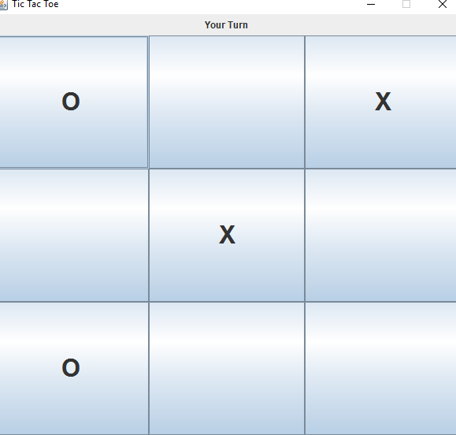

In the above example, user will make a move into the 5th block, computer will make a move into the 1st block, again user will make a winning move into the 3rd block, now computer will block the user from winning by making a move into the 7th block.

2. 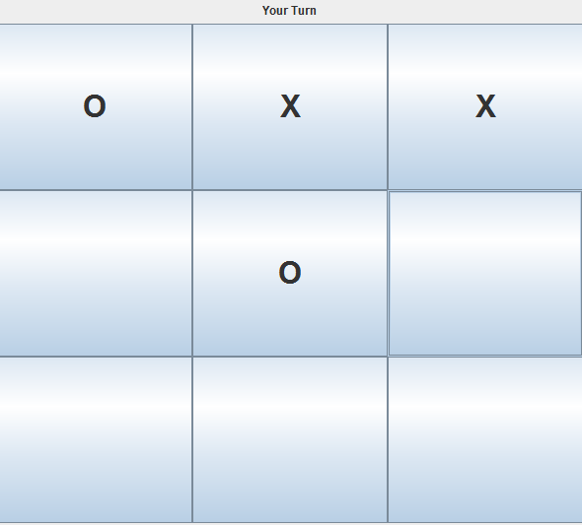

In the above example, first user will place in 2nd block, computer will place in 5th block, again user places in 3rdblock, here, computer will block the user move from winning by placing in 1stblock.

User winning chances

1.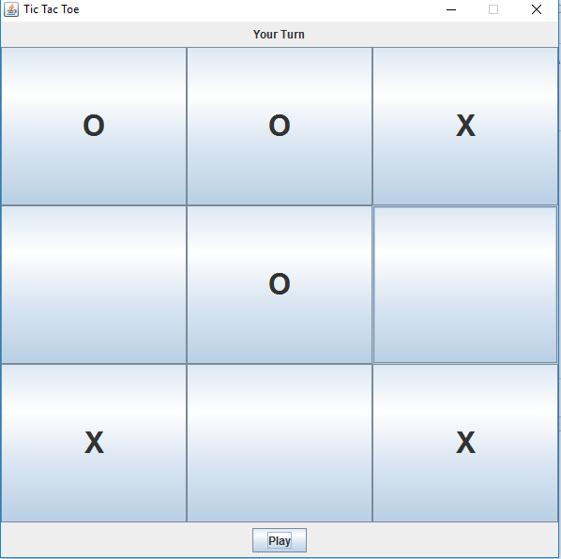

If the user places a move in either 6th block or 8th block then the user wins.

**2.**

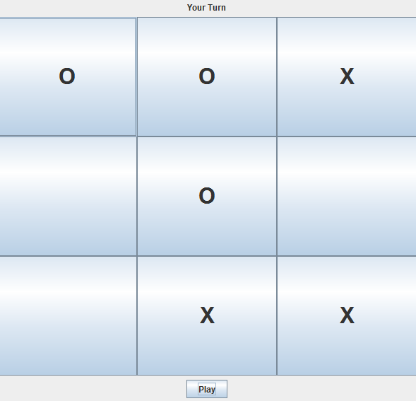

If the user places a move in either 6th or 7th block then the user wins.

**CONCLUSION AND FUTURE SCOPE**

**5.1 Conclusion**

This report presents the implementation of Tic-Tac-Toe Game (A Constraint Satisfaction Problem - CSP) by analyzing human moves with the system. By using Java Programming Language we generate the computer moves in the game. We have implemented nxn version in general, 3x3 version in particular. The main aim of implementing this code is to make a system react to the moves of the human and try to win over humans.

**5.2 Future Scope**

We can add more features to the game and also can implement 3x3 on a larger nxn grid.

**REFERENCES**

[1] Wikipedia

[2] Stack Overflow

[3]Object Oriented Program (Black Book) by Nageswara Rao